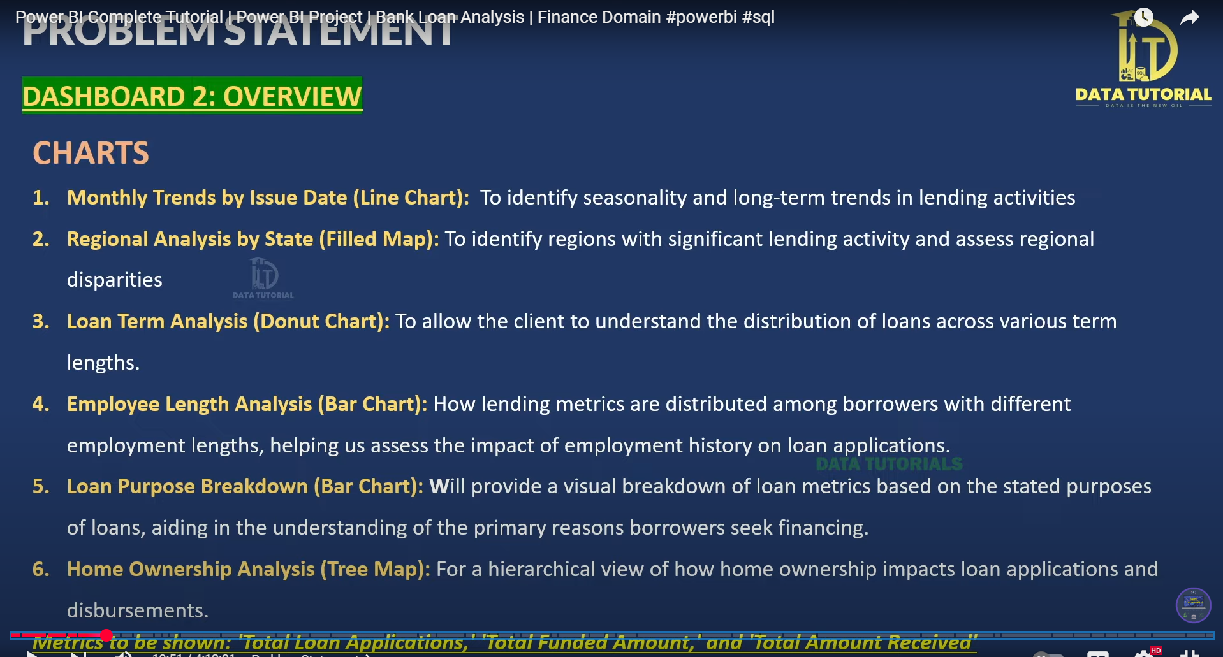

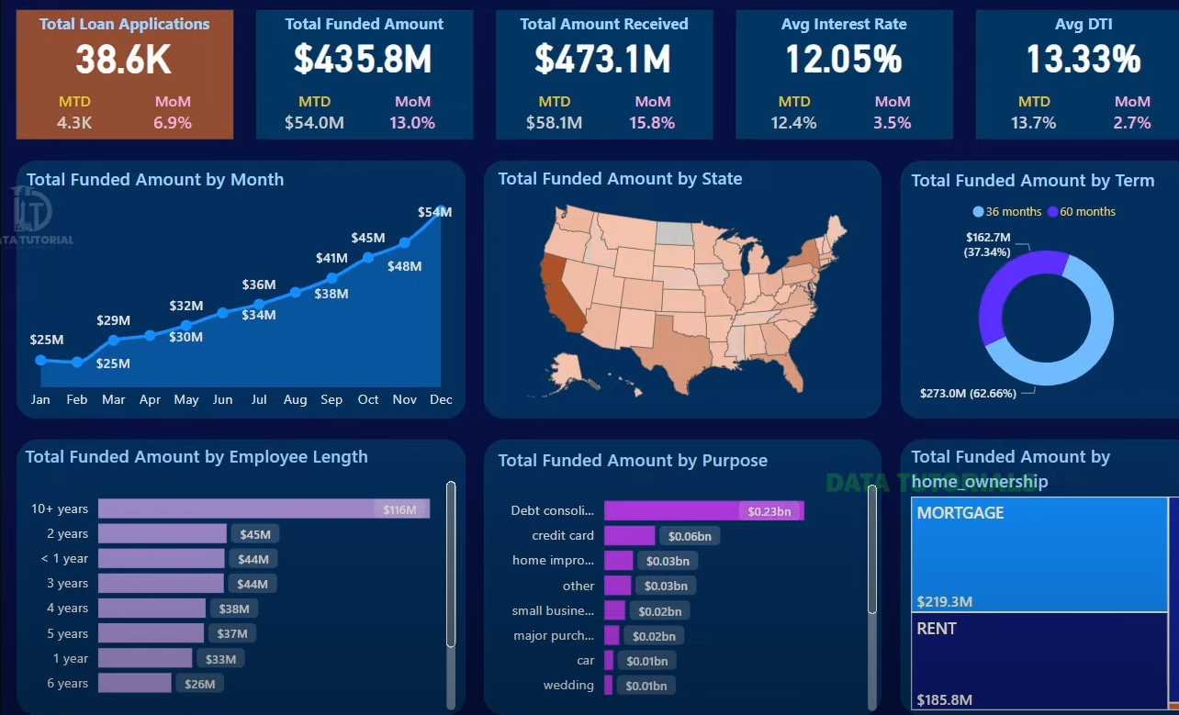

Of course. Let's go through the purpose of each chart, connecting the "Problem Statement" slide with the final dashboard.

The main goal of this dashboard is to give a **high-level overview** of the bank's lending performance by looking at the data from different angles.

**1. Monthly Trends by Issue Date (Line Chart)**

* **Purpose:** To see how lending activity changes over time. The line chart is perfect for showing trends.
* **Business Questions it Answers:**
  + **Seasonality:** Are there specific months when we give out more loans (e.g., during holidays or summer)?
  + **Long-Term Trend:** Is the total amount we are lending generally increasing or decreasing over the year?
* **On the Dashboard:** This is the **"Total Funded Amount by Month"** chart in the top-left corner. You can clearly see an upward trend from January to December.

**2. Regional Analysis by State (Filled Map)**

* **Purpose:** To quickly see the geographic distribution of loans. The map visually highlights areas with high or low lending activity.
* **Business Questions it Answers:**
  + Which states are our biggest markets?
  + Are there regions where we have little or no presence?
* **On the Dashboard:** This is the **"Total Funded Amount by State"** map. The darker the color of the state, the more money has been loaned there.

**3. Loan Term Analysis (Donut Chart)**

* **Purpose:** To understand the popularity of different loan lengths (e.g., 36 months vs. 60 months). A donut chart is great for showing the proportions or percentage split of a whole.
* **Business Questions it Answers:**
  + What is the mix of our short-term vs. long-term loans?
  + Are customers preferring one loan term significantly over another?
* **On the Dashboard:** This is the **"Total Funded Amount"** donut chart on the top right. It shows that 62.66% of the funded amount is for 60-month loans.

**4. Employee Length Analysis (Bar Chart)**

* **Purpose:** To see if there's a connection between a borrower's employment history and the loan amount. A bar chart is used to compare values across different categories.
* **Business Questions it Answers:**
  + Do people with longer and more stable job histories (e.g., 10+ years) tend to borrow more money?
  + How much do we lend to people who are relatively new to their jobs (e.g., < 1 year)?
* **On the Dashboard:** This is the **"Total Funded Amount by Employee Length"** chart. It compares the total loan amounts for people with different years of employment.

**5. Loan Purpose Breakdown (Bar Chart)**

* **Purpose:** To find out the main reasons why people are borrowing money. Like the chart above, a bar chart helps compare the total amounts for each category.
* **Business Questions it Answers:**
  + What is the most common reason for loans? (e.g., Debt consolidation, credit card debt, home improvement).
  + Which purposes should our marketing campaigns focus on?
* **On the Dashboard:** This is the **"Total Funded Amount by Purpose"** chart. It clearly shows that "Debt consolidation" is the biggest reason people borrow.

**6. Home Ownership Analysis (Tree Map)**

* **Purpose:** To understand how a borrower's housing situation (renting vs. owning) relates to the loan amounts. A tree map is another good way to show proportions, where the size of the rectangle represents the value.
* **Business Questions it Answers:**
  + Do we lend more money in total to homeowners (Mortgage) or to renters?
  + What is the financial breakdown of our loan portfolio based on homeownership status?
* **On the Dashboard:** This is the **"Total Funded Amount by home_ownership"** chart. The larger "MORTGAGE" box shows that more funds are loaned to people who own their homes.

Each chart in the Power BI loan analysis project for the bank provides specific insights about lending patterns, customer behavior, and risk factors in the loan portfolio.[novypro+1](https://www.novypro.com/project/bank-loan-analysis-dashboard-8)

**Monthly Trends by Issue Date (Line Chart)**

This chart shows how many loans are issued each month over time, making it easy to identify seasonality and long-term trends. For example, it can reveal which months typically see higher or lower lending activity, helping the bank plan resources or spot emerging patterns.[github+1](https://github.com/vinayak200227/Bank-Loan-Analysis-using-PowerBI)loan1.jpg

**Regional Analysis by State (Filled Map)**

A filled map highlights which states or regions have significant lending activity and where disparities exist. This helps the bank target marketing campaigns or investigate why some areas have more loan demand or higher risk profiles.loan1.jpg[novypro+1](https://www.novypro.com/project/bank-loan-analysis-dashboard-8)

**Loan Term Analysis (Donut Chart)**

This donut chart displays the breakdown of loans by term length (like 12, 24, or 36 months), letting users see what proportion of borrowers prefer short-term versus long-term loans. It gives insight into customers’ repayment preferences and how loan products are being used.[novypro+1](https://www.novypro.com/project/bank-loan-analysis-dashboard-8)loan1.jpg

**Employee Length Analysis (Bar Chart)**

This bar chart analyzes how lending metrics vary depending on how long loan applicants have been employed. It helps show if applicants with longer job tenure are more likely to get loans or have different loan sizes, which can be useful for assessing credit risk.[github+1](https://github.com/vinayak200227/Bank-Loan-Analysis-using-PowerBI)loan1.jpg

**Loan Purpose Breakdown (Bar Chart)**

This visual shows data about why people take out loans, breaking down by categories (such as home improvement, education, business, etc.). It helps the bank understand the main reasons customers seek financing and which purposes might carry higher risk.loan1.jpg[novypro+1](https://www.novypro.com/project/bank-loan-analysis-dashboard-8)

**Home Ownership Analysis (Tree Map)**

A tree map gives a hierarchical view of lending and repayments based on home ownership status (such as mortgage, rent, own). This helps reveal how owning a home influences the likelihood of applying for loans and the success rate of repayments.[novypro+1](https://www.novypro.com/project/bank-loan-analysis-dashboard-8)loan1.jpg

**Metrics Tracked**

For each of these charts, the dashboard tracks key metrics:

* Total Loan Applications: Number of loan applications received.[github+1](https://github.com/vinayak200227/Bank-Loan-Analysis-using-PowerBI)loan1.jpg
* Total Funded Amount: How much loan money was disbursed.
* Total Amount Received: The repayments or money received back from borrowers.

Altogether, these visualizations provide a comprehensive, data-driven overview for managing risk, targeting products, and improving business strategy in the lending lifecycle.loan1.jpg[novypro+1](https://www.novypro.com/project/bank-loan-analysis-dashboard-8)

1. <https://www.novypro.com/project/bank-loan-analysis-dashboard-8>
2. <https://github.com/vinayak200227/Bank-Loan-Analysis-using-PowerBI>
3. <https://ppl-ai-file-upload.s3.amazonaws.com/web/direct-files/attachments/images/65478928/bc61633b-1493-4b34-9aba-7428461b6b0b/loan1.jpg>
4. <https://www.youtube.com/watch?v=3I8wd1AShXs>
5. <https://www.kaggle.com/datasets/sanjanamurthy392/bank-loan-analysis-project-in-power-bi>
6. <https://www.youtube.com/watch?v=3HZA-WxdxF8>
7. <https://www.linkedin.com/posts/elise-nshuti_powerbi-loananalytics-finance-activity-7334983281727131648-gdKZ>
8. <https://www.scribd.com/presentation/798816535/Bank-Loan-PPT-Power-BI>
9. <https://www.slideshare.net/slideshow/project-name-bank-loan-analytics/271546171>
10. <https://www.venasolutions.com/blog/power-bi-dashboards-examples>